AI Use Declaration Form
Course: Introduction to Artificial Intelligence
Lab Title: Lab 1 Part A — Uninformed Search Algorithms
Student Name: _______Deborah Maame Araba Koufie____________________________________________
Student ID: _____________________46332028_________________________________
GitHub Repository Link: ____________________________https://github.com/maameaa18/ai-course-lab0/tree/main/Koufie_Deborah_Lab0_______________
Date Submitted: _________________5th June 2026_________________________________

1. AI Use Summary
Question | Student Response
Did you use any AI tool for this lab? | Yes
Estimated percentage of the work influenced by AI | 65 %
Did you attach evidence of AI use where applicable? | Yes

2. Details of AI Use
Complete the table below for each AI tool used. Add more rows where necessary.
Name of AI Tool Used | Purpose for Using the Tool | Prompt or Instruction Given to the Tool | Part(s) of the Work Influenced by the Tool | How I Verified, Edited, or Improved the AI Output
ChatGPT | To navigate the assignment and paste commands into the terminal to find my folder |  | The codes | I just run them in the terminal and they gave me what I was expecting

3. Attachment of AI Output Evidence
Where required, attach evidence of AI use. Tick all that apply. Add more rows where necessary.
Evidence Type | Attached? (Yes, No, N/A) | File Name
AI-generated draft | I shared the GitHub lab instruction link and asked ChatGPT to help me understand what the lab required. I asked for a breakdown of the required files, including environment_test.py, environment_verification.txt, colab_practice.ipynb, lab0_exercises.ipynb, the README file, and the GitHub repository structure.
Prompt history
Screenshot of AI interaction | 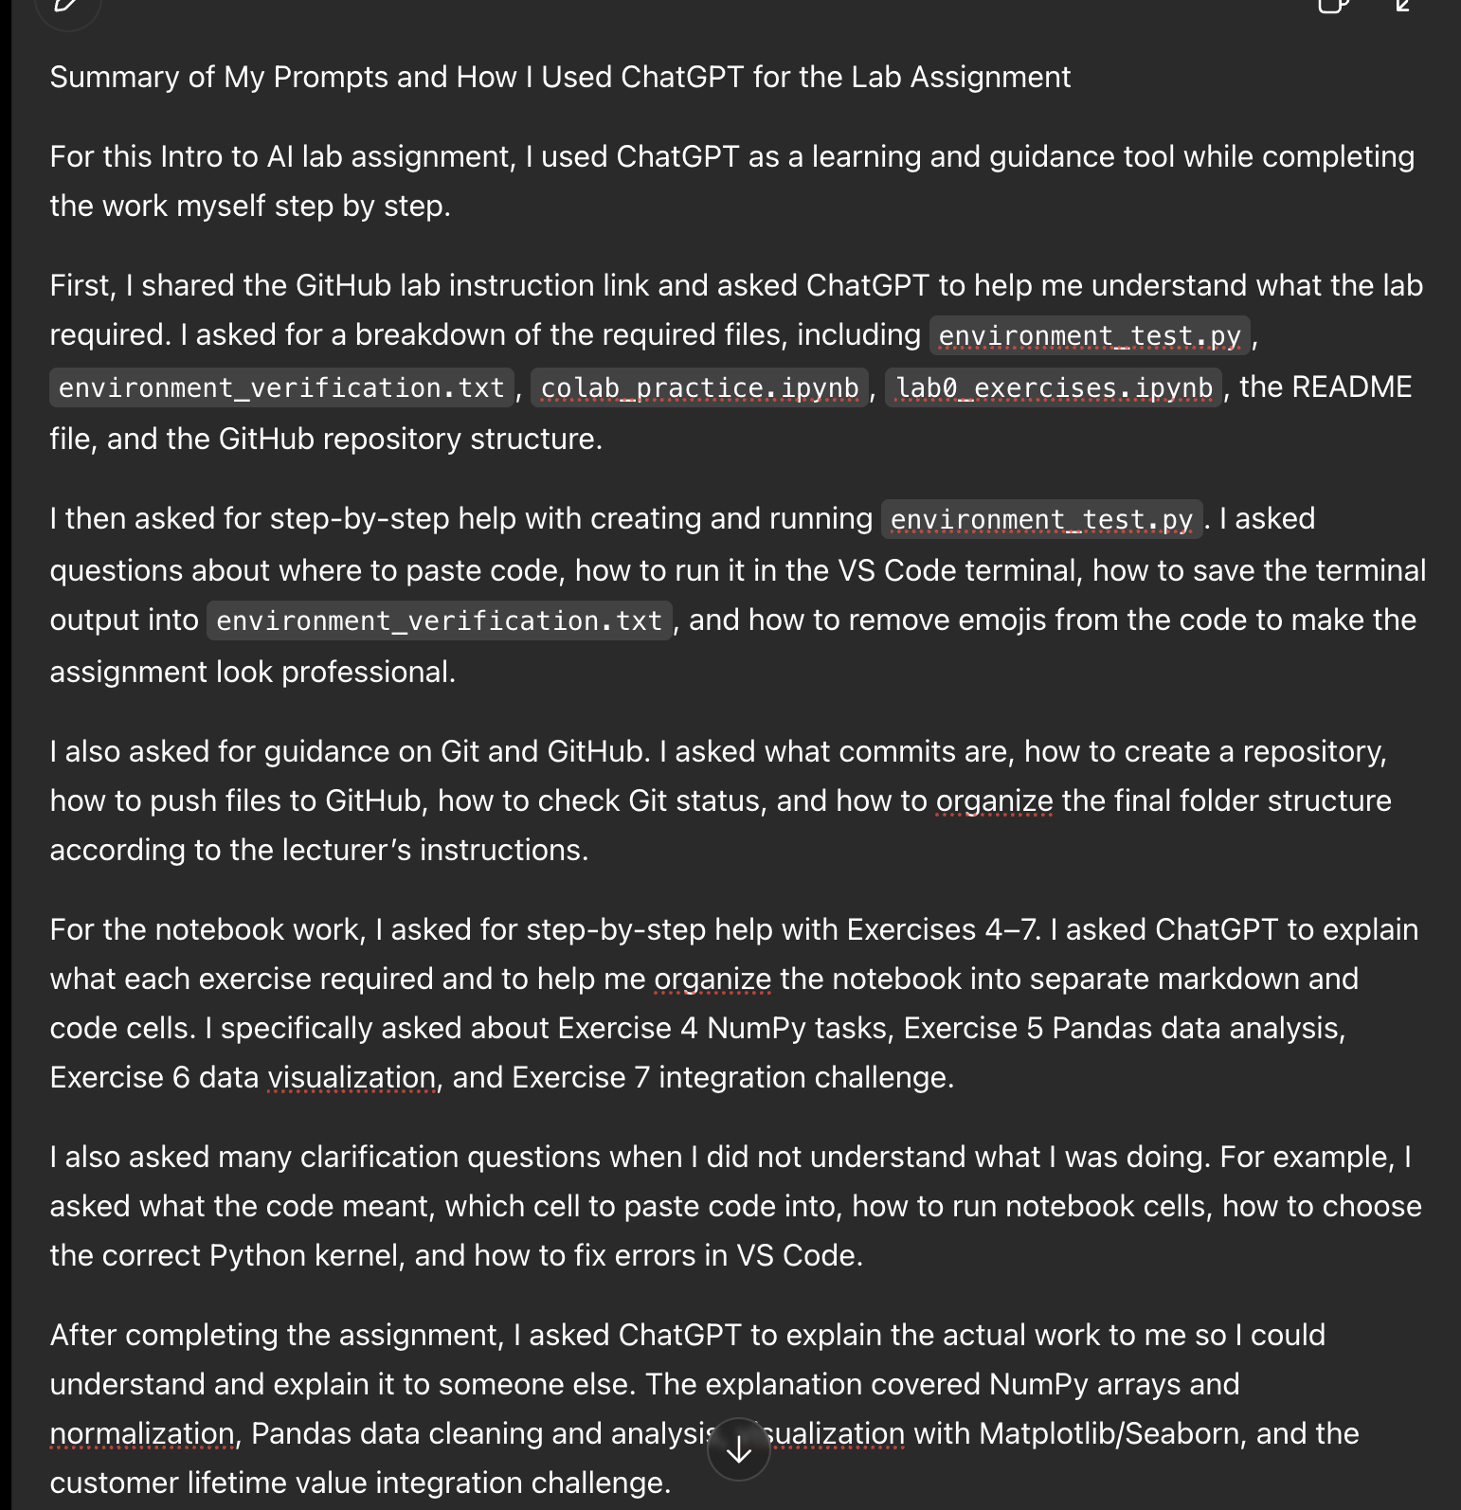
Exported AI conversation
AI-generated code snippet
Revised version showing student input

4. Student Declaration
I declare that:
Declaration Statement | Response (Yes/No)
The submitted work is my own work.
Any use of AI tools has been clearly declared in this form. | Yes
The prompts, instructions, and AI-generated outputs have been disclosed where applicable. | Yes
I reviewed, tested, edited, and improved any AI-generated content before submission. | Yes
My AI usage does not exceed 25% of the entire work.
I understand that undeclared or excessive AI use may be treated as academic misconduct. | Yes

Student Signature: ______Araba Koufie_____________________________________
Date: ______5th June 2026_____________________________________

